Mobile App Statistics

# Apple iOS app store:

The ever-changing mobile landscape is a challenging space to navigate. The percentage of mobile over desktop is only increasing.

Android holds about 53.2% of the smartphone market, while iOS is 43%. To get more people to download your app, you need to make sure they can easily find your app.

Mobile app analytics is a great way to understand the existing strategy to drive growth and retention of future user.

With million of apps around nowadays, the following data set has become very key to getting top trending apps in iOS app store.

This data set contains more than 7000 Apple iOS mobile application details. The data was extracted from the iTunes Search API at the Apple Inc website.

## Structure of the dataset:

* There are 7197 observation about apps in the US iOS app store in our dataset with 16 features. Categorical Variables Are: prime_genre, currency, user_rating, cont_rating, is_game. Numerical Variables Are: price, rating_count_tot, size_bytes, size_mb, user_rating_ver, ver, rating_count_ver.
* The primary category for most of the observation are about Games, the rest are for general apps.

Price can be divided into Free or Paid.

75% of apps are less than $2 in price and have average rating of 4.5

The main features of interest in our dataset are the app details like price, and user rating.

Language Supported and size may be useful in future state to determine the relation between ratings.

All currencies in our dataset are USD. Which means no need to check any other currency for this dataset.

## Observations, Insights and Learning

* Count plot as per free/not free apps

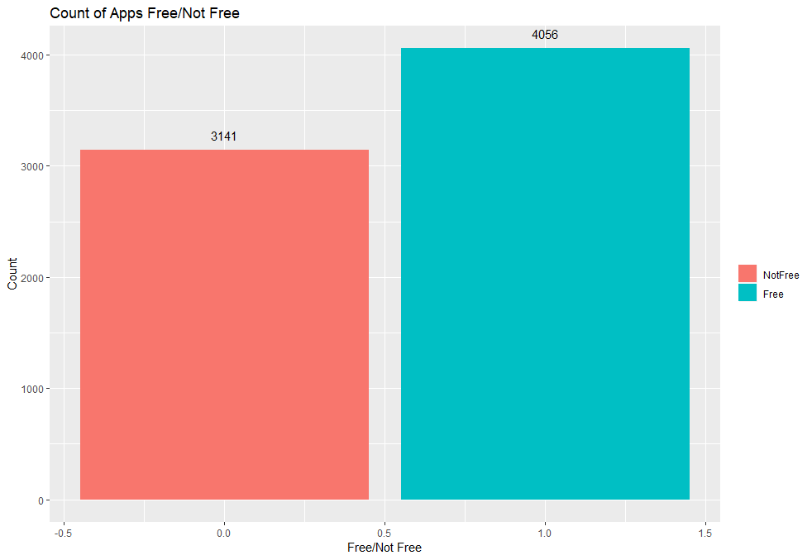

* Showing frequency of apps based on category sorted by their count

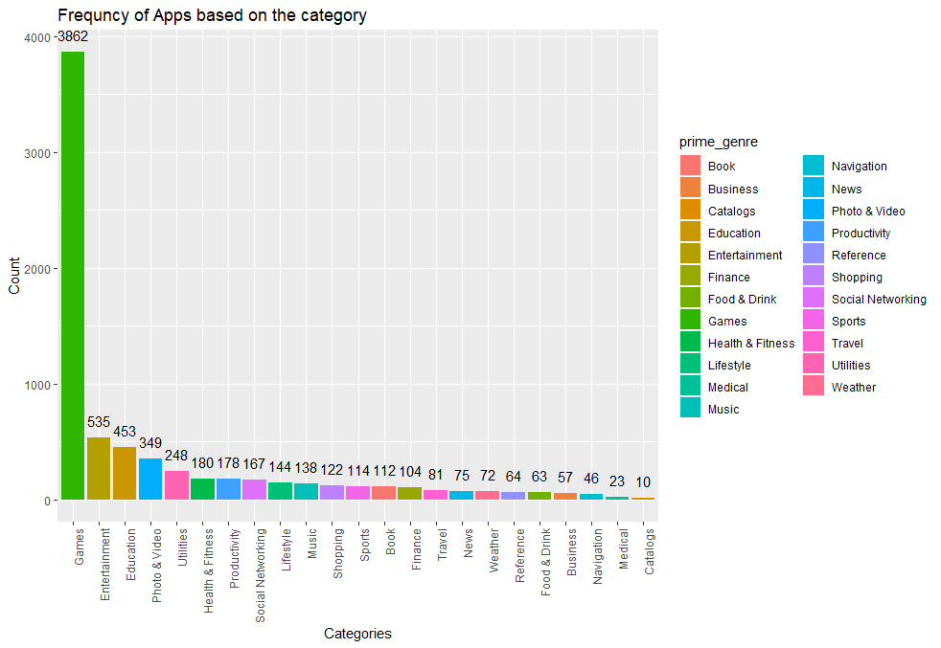

* Showing frequency of apps based on content category

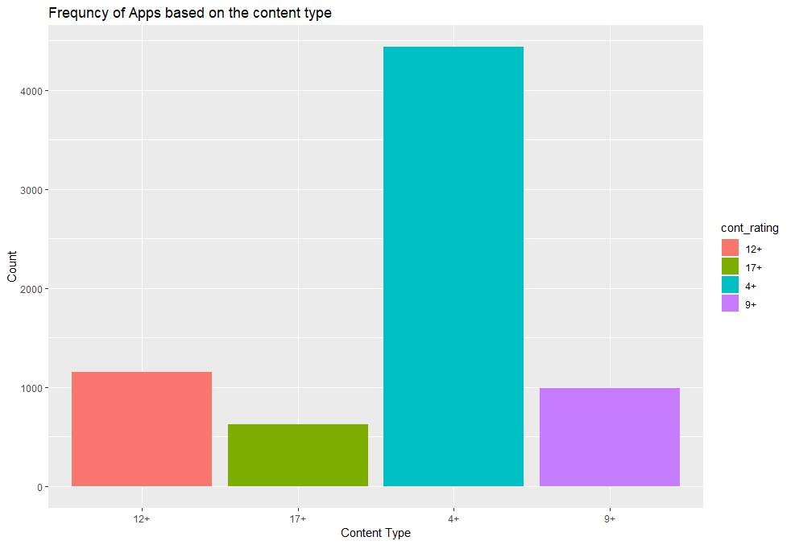

* Showing frequency of Apps based on the user rating above 0

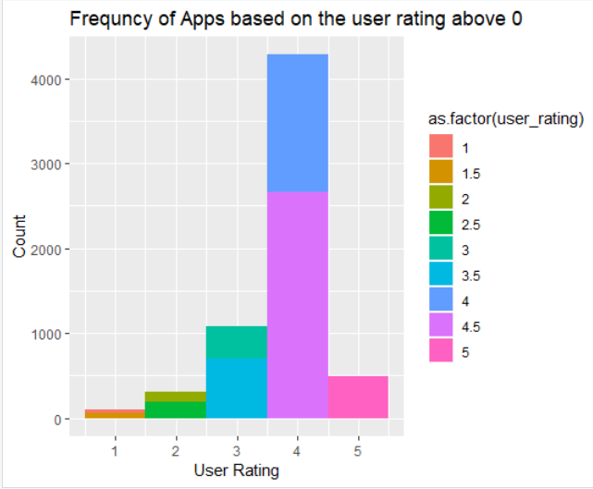

* + We excluded 0 rating from our apps to better investigate the dataset.
  + Most of the apps are rated 4.5 and very few are rated as average 5.
  + We also separated data by Games and non-Games category.
* Top 10 Games based on user rating and total number of ratings

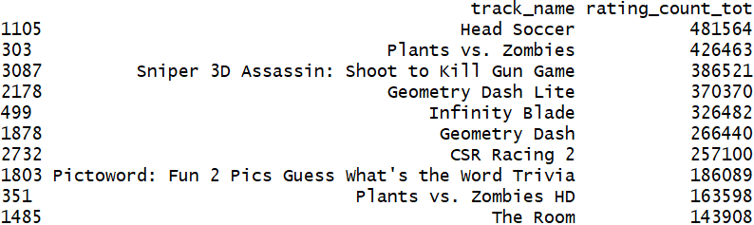

* Top 10 General apps based on user rating and total number of ratings

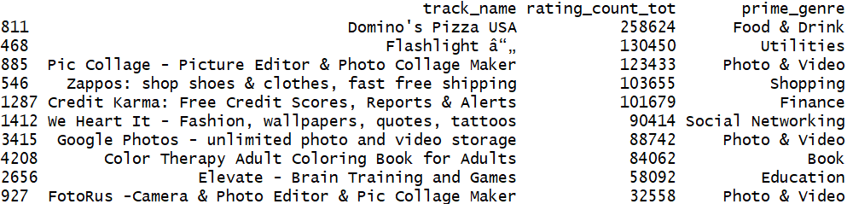

* An overview of all variables together, gives a quick look to the relation between each variable and the rest of them.

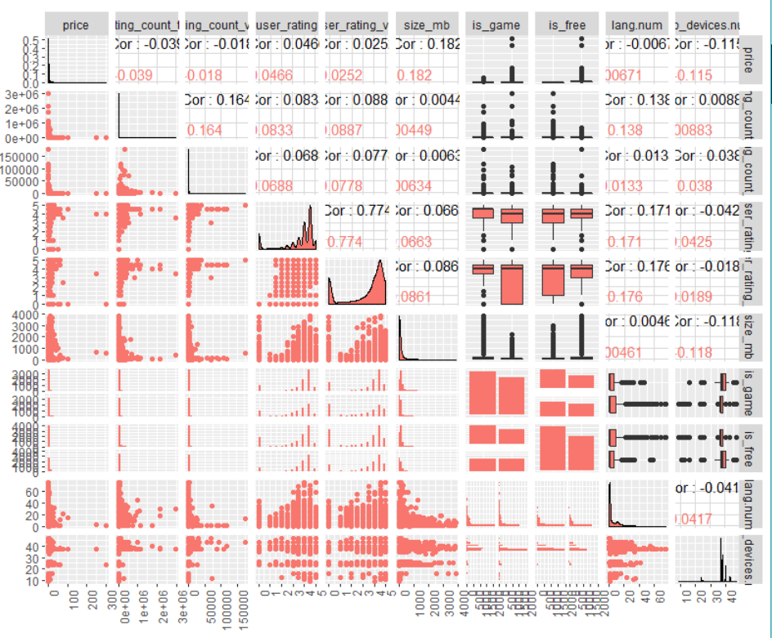

* A quick look to correlation between our numeric columns.

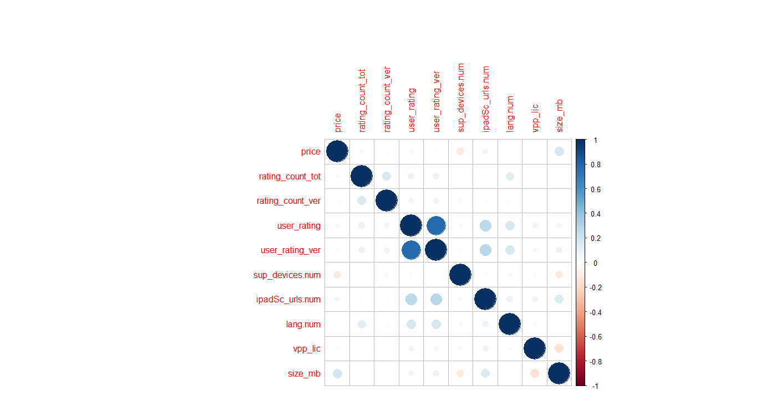

* A plotting point showing the relation between price of an app and it's mean user rating.

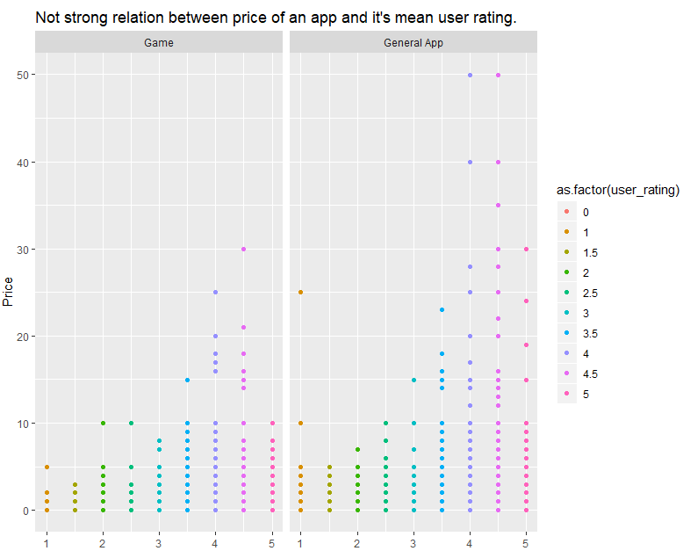

As we see there are some outer points in general apps for 4-5 ratings, which fairly indicates that user rating/quality for a general app may be the reason for increasing the price.

* A plot line showing the relation between number of languages supported by an app and it's quality/user rating.

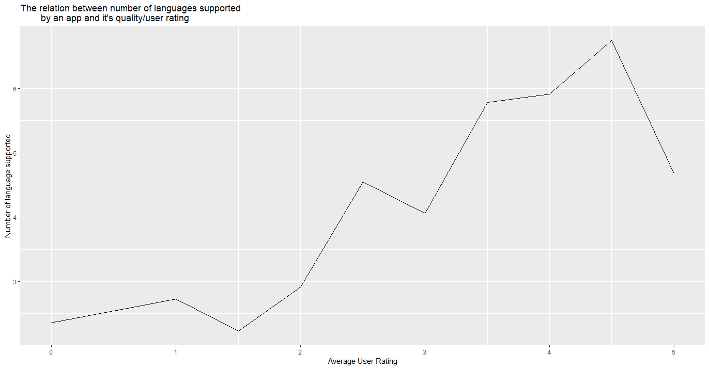

Yes, number of languages supported by an app may affect on it's total rating.

* Showing the relation between number of devices supported by an app and it's quality/user rating

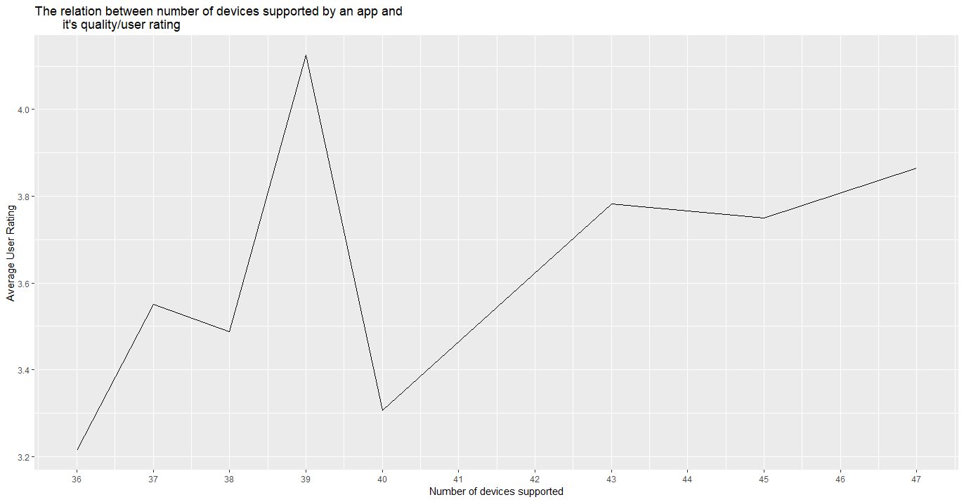

* + The minimum number of supported devices is 9. Median is 37
  + 75% of the apps have 39 supported devices or less.
  + Correlation between user rating and supported devices is negative.
* A boxplot plot for content rating as a categorical value and price for an app

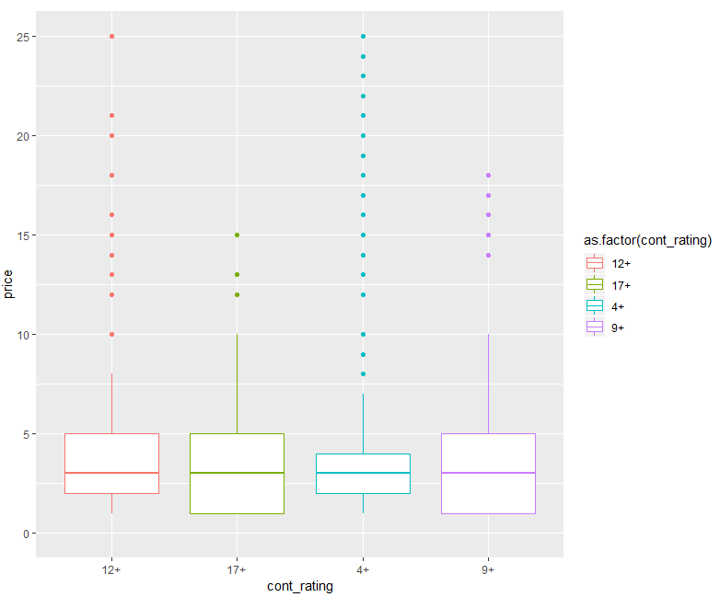

* + All content-based apps are nearly having 3 in user rating.
  + 25% of 12+ apps have prices less than $5.
  + 9+ and 17+ are nearly the same in regarding of the price.
  + 4+ apps which include high number of games are less than $3.
* A histogram showing the relation between user ratings and an app category.

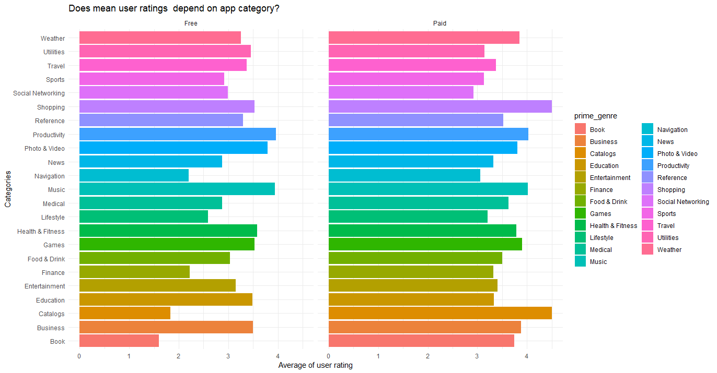

* + Productivity and Music have the highest average rating in free apps.
  + Catalogues and Shopping have the highest average rating in paid apps.
* A histogram showing total number of user ratings and app category.

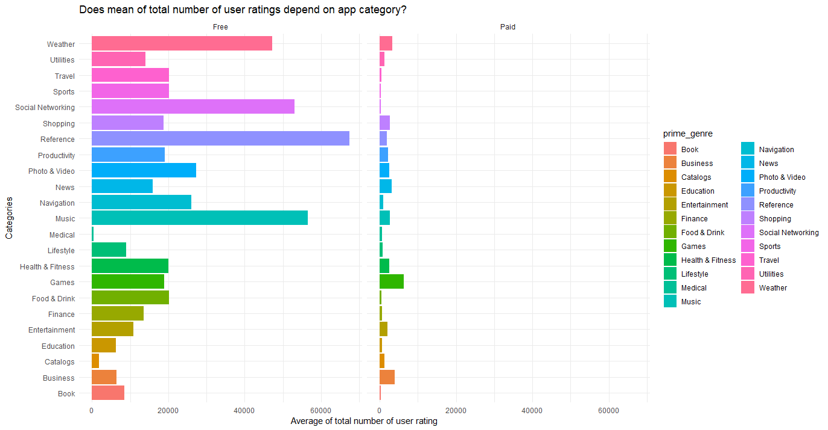

Users don't give feedback or rating to paid apps. However, they do in free apps!

* A histogram plot answering question of: Which category is more expensive than other apps?

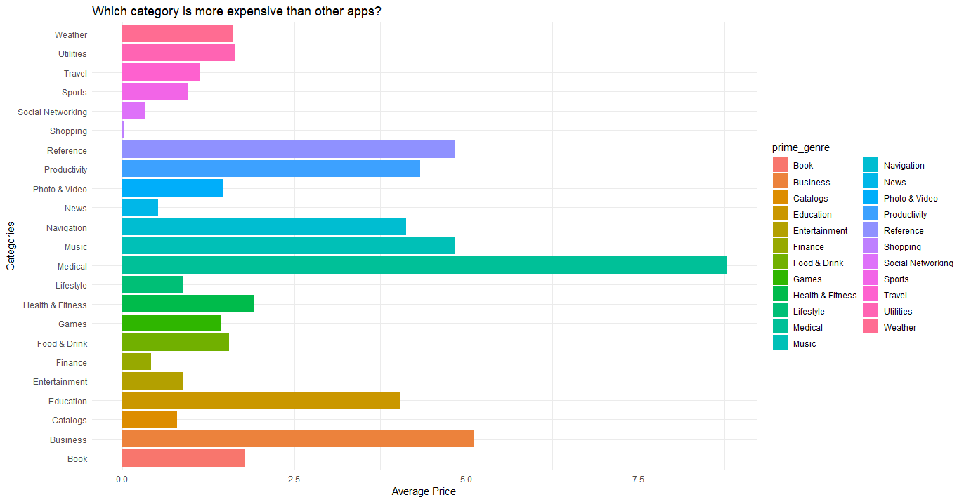

* Line plot showing the relation between current version rating and average user rating for an app.

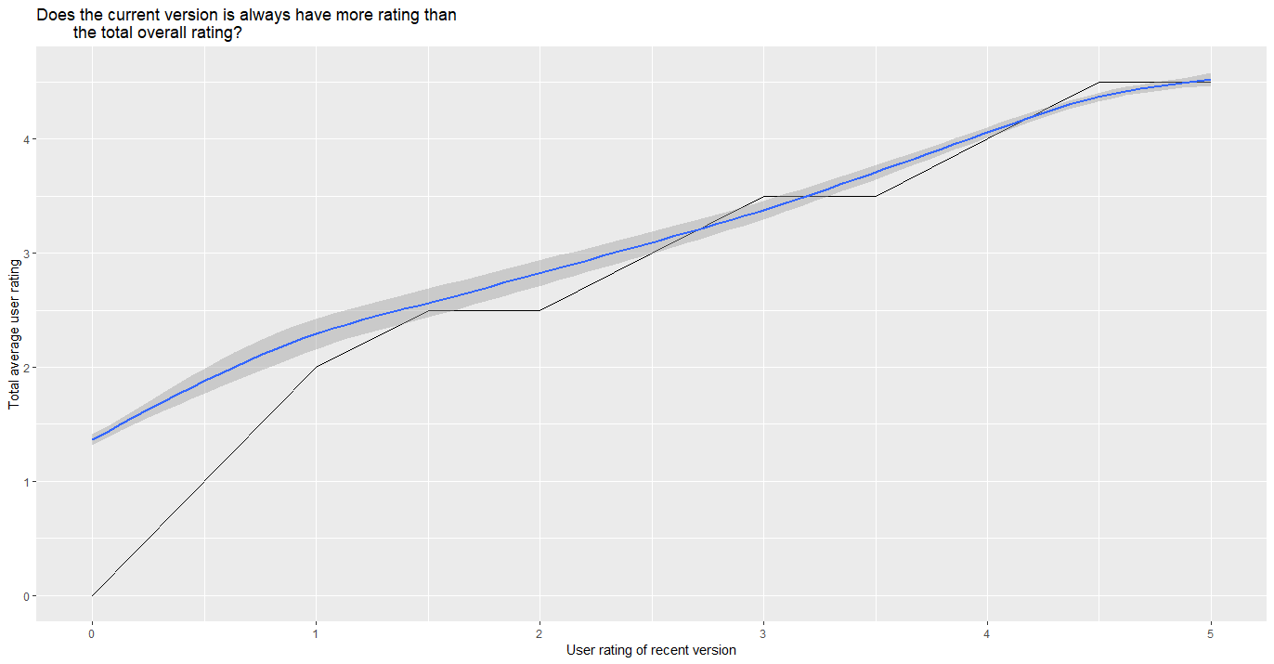

Correlation between current version user rating and total overall user rating is 0.7 which leads to a strong positive correlation between them as the above plot shows.

* A histogram showing the summary of size_mb (MEAN) and user rating.

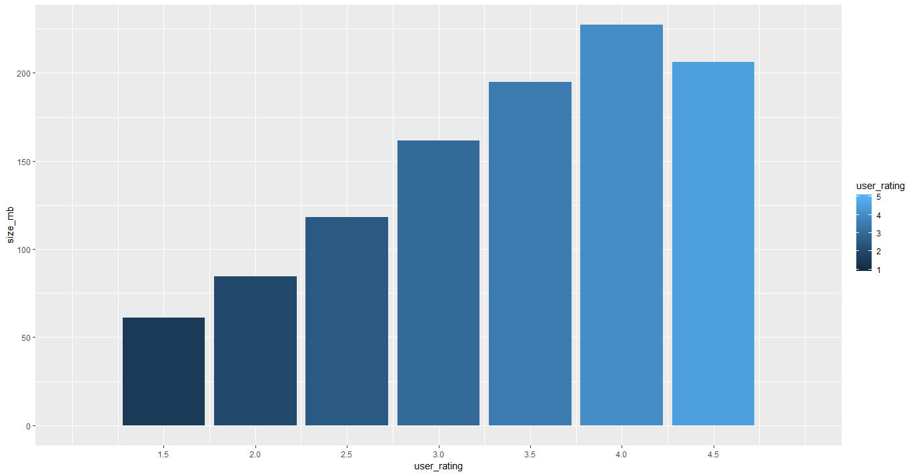

* Showing two plots for size and total number of ratings and price colored by user rating

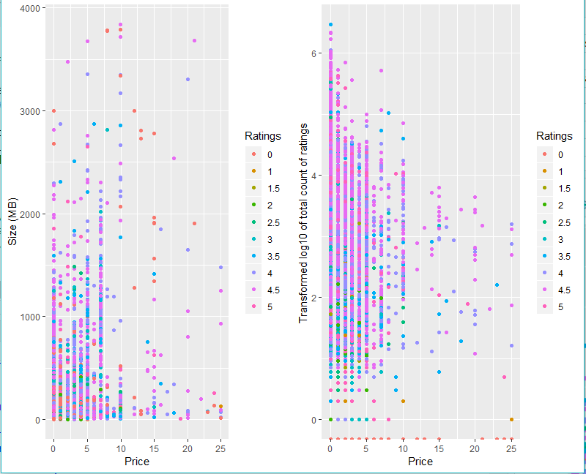

* Plotting final summary:
  + Prices based on categories

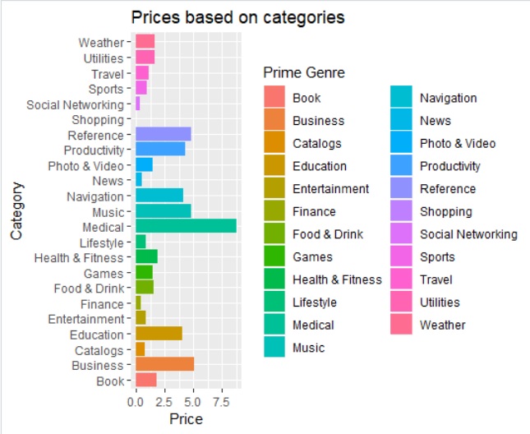

* + User rating based on categories

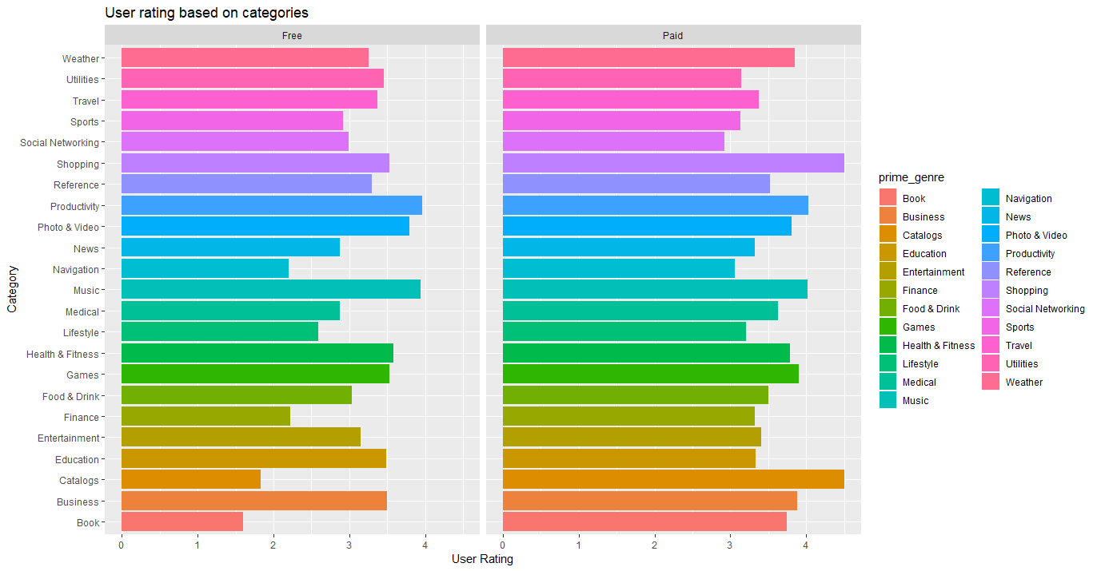

* Top 10 apps based on total count of user rating:

17 Facebook 2974676

591 Instagram 2161558

1561 Clash of Clans 2130805

810 Temple Run 1724546

8 Pandora - Music & Radio 1126879

863 Pinterest 1061624

5 Bible 985920

1731 Candy Crush Saga 961794

202 Spotify Music 878563

310 Angry Birds 824451

## Description One

Medical app category is the most expensive ones.

The category field can affect the price of the app!

Shopping and finance apps have less price than other apps. Make sense because they provide services and users already pay to use the service.

## Description Two

Newer versions of most of the apps have better rating than the median rating.

Developers always try to publish a better app that worth a better rating always.

## Description Three

What is the relation between user rating, price and app size?

Average user rating increases with good reviews while app size increases!

It seems users give good rating for large sized apps!

App size clearly does not affect the price of the app.

Games are more stable in price even if the app size being increased.

Categories based on average user rating?

1. Productivity and Music have the highest average rating in free apps.

2. Catalogues and Shopping have the highest average rating in paid apps.

3. Books in paid apps have high mean rating, however very less in free apps. The same in Catalogues. Books paid app worth the money.

Top 3 apps based on total number of user ratings:

1. Facebook (General App)

2. Instagram (General App)

3. Clash of Clans (Game)

Top 3 apps based on average user ratings:

1. Domino's Pizza USA (General App)

2. Flashlight (General App)

3. Head Soccer (Game)

4. Plants vs. Zombies (Game)

# Google App Store

# 

While many public datasets (on Kaggle and the like) provide Apple App Store data, there are not many counterpart datasets available for Google Play Store apps anywhere on the web.

On the other hand, Google Play Store uses sophisticated modern-day techniques (like dynamic page load) using JQuery making scraping more challenging.

Each app (row) has values for category, rating, size, and more.

The Play Store apps data has enormous potential to drive app-making businesses to success. Actionable insights can be drawn for developers to work on and capture the Android market!

## Observations, Insights and Learning

* Installations by Type

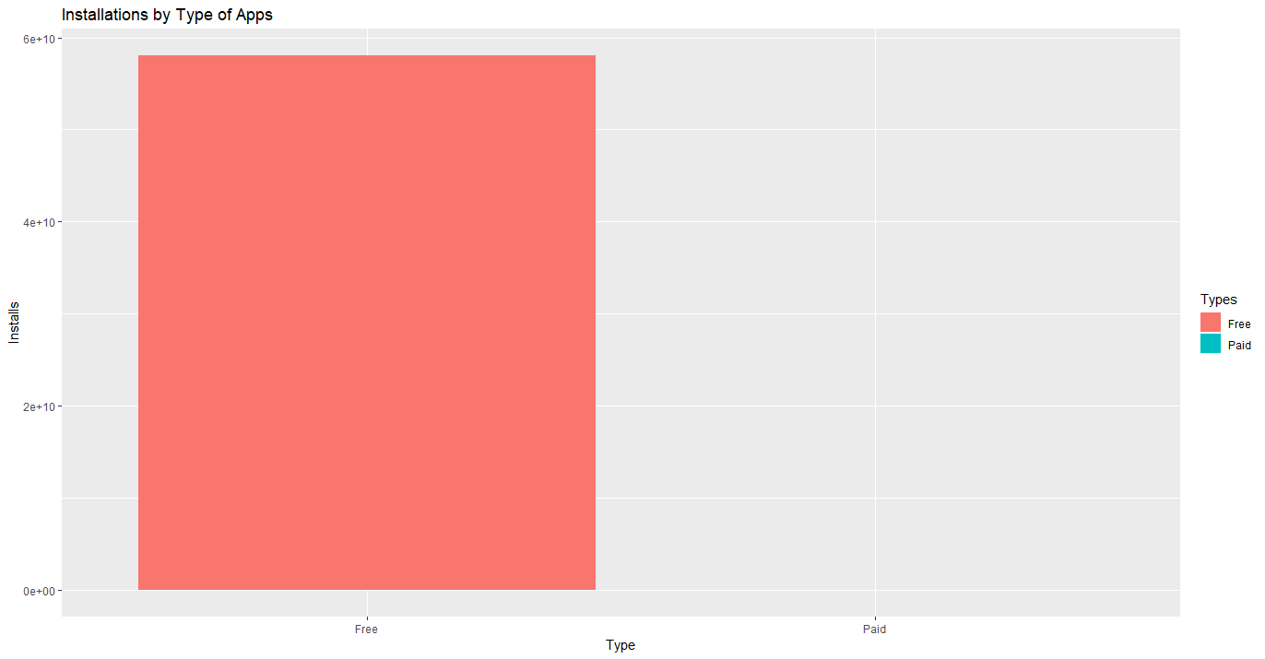

* Installations by Categories

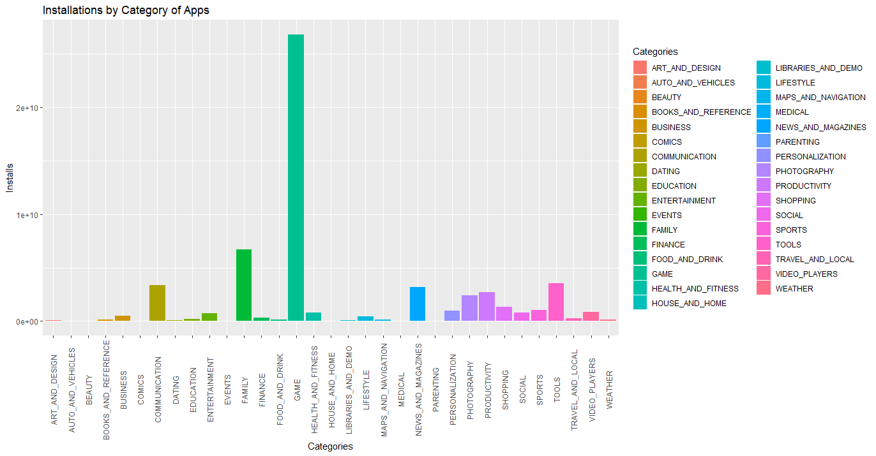

* Since Game has more installations let’s see the most installed Apps under it

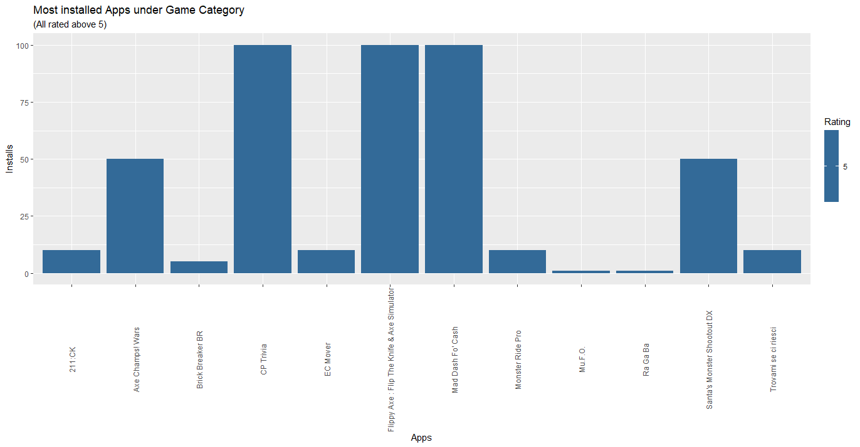

* Most Family Apps installed

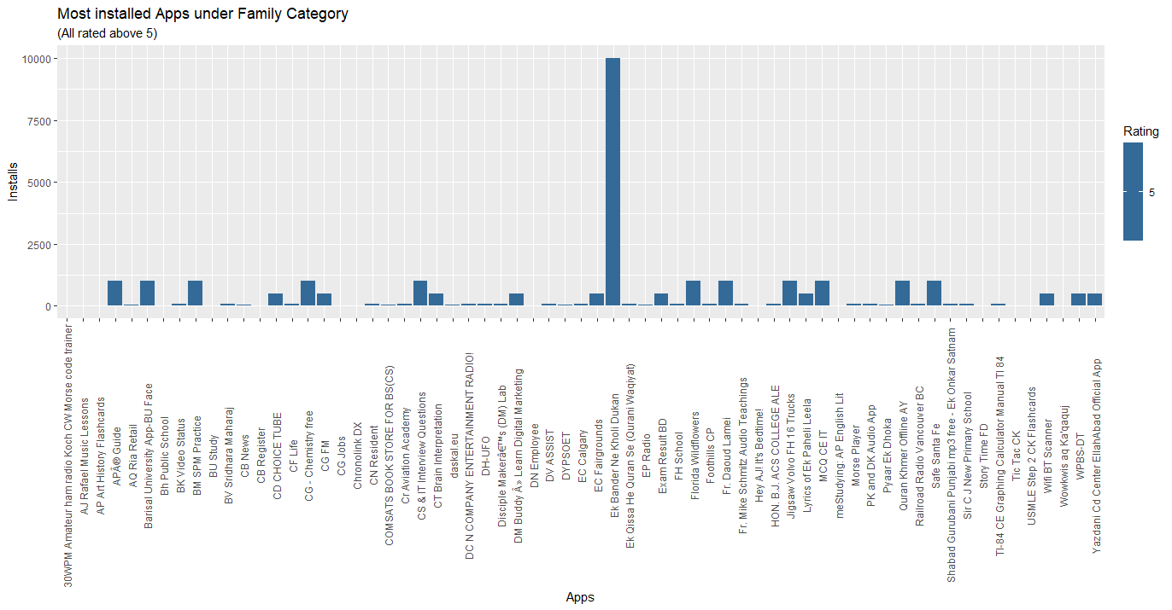

* Let's Analyze content rating and Installs

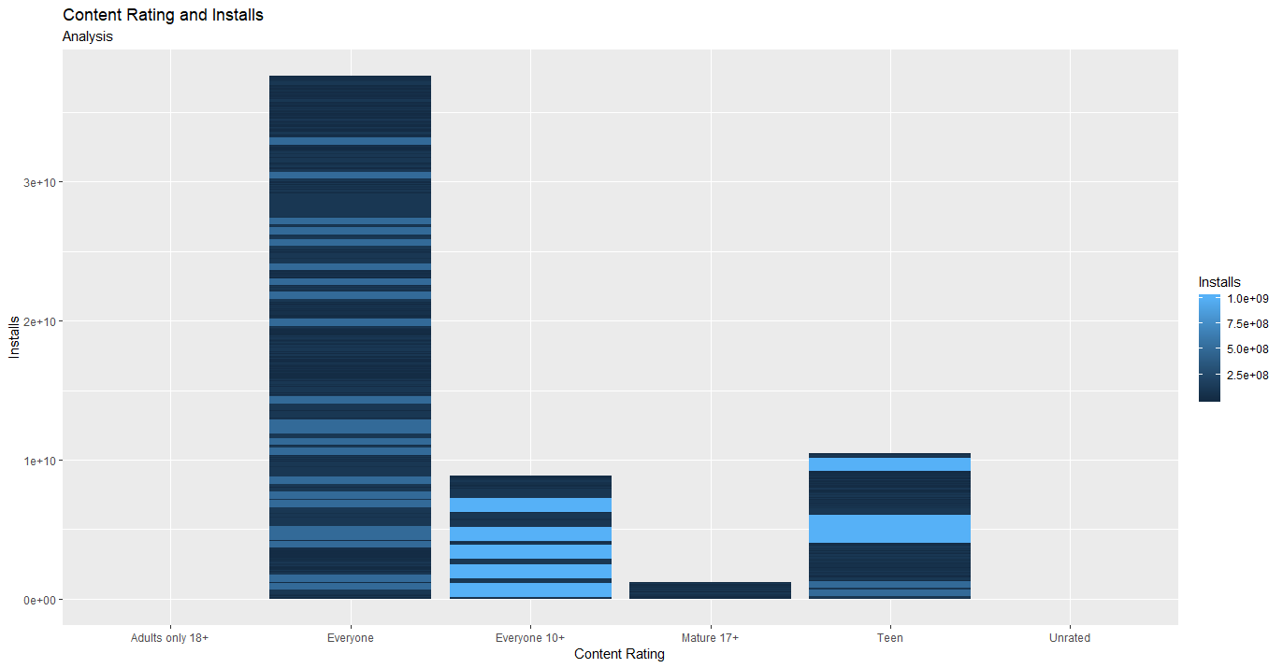

* Check what category has the highest rating

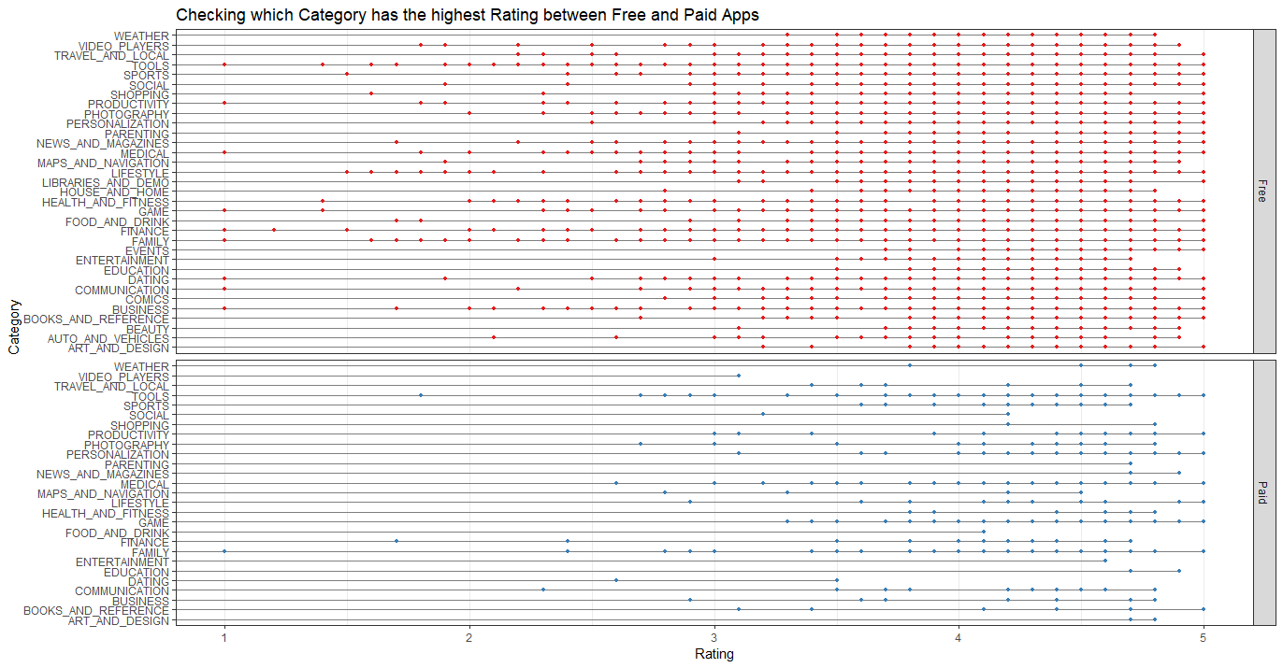

* Number of App ratings based on category and type

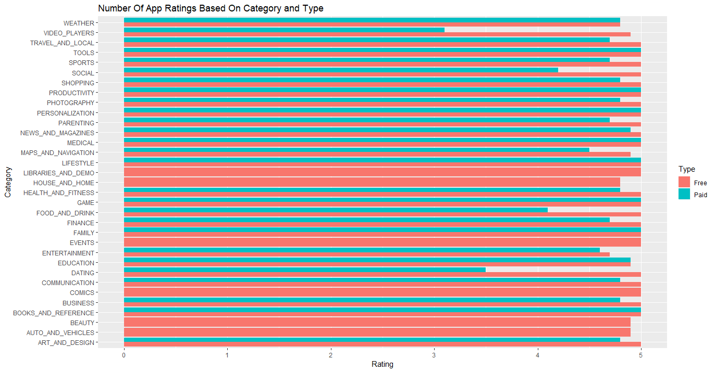

* Number of App reviews based on category and type

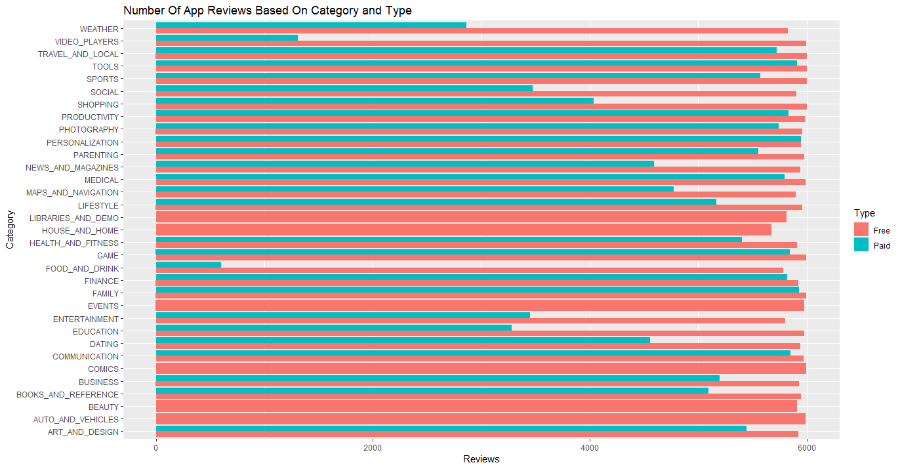

* Number of App installs based on category and type

